***APPLICATION FORM***

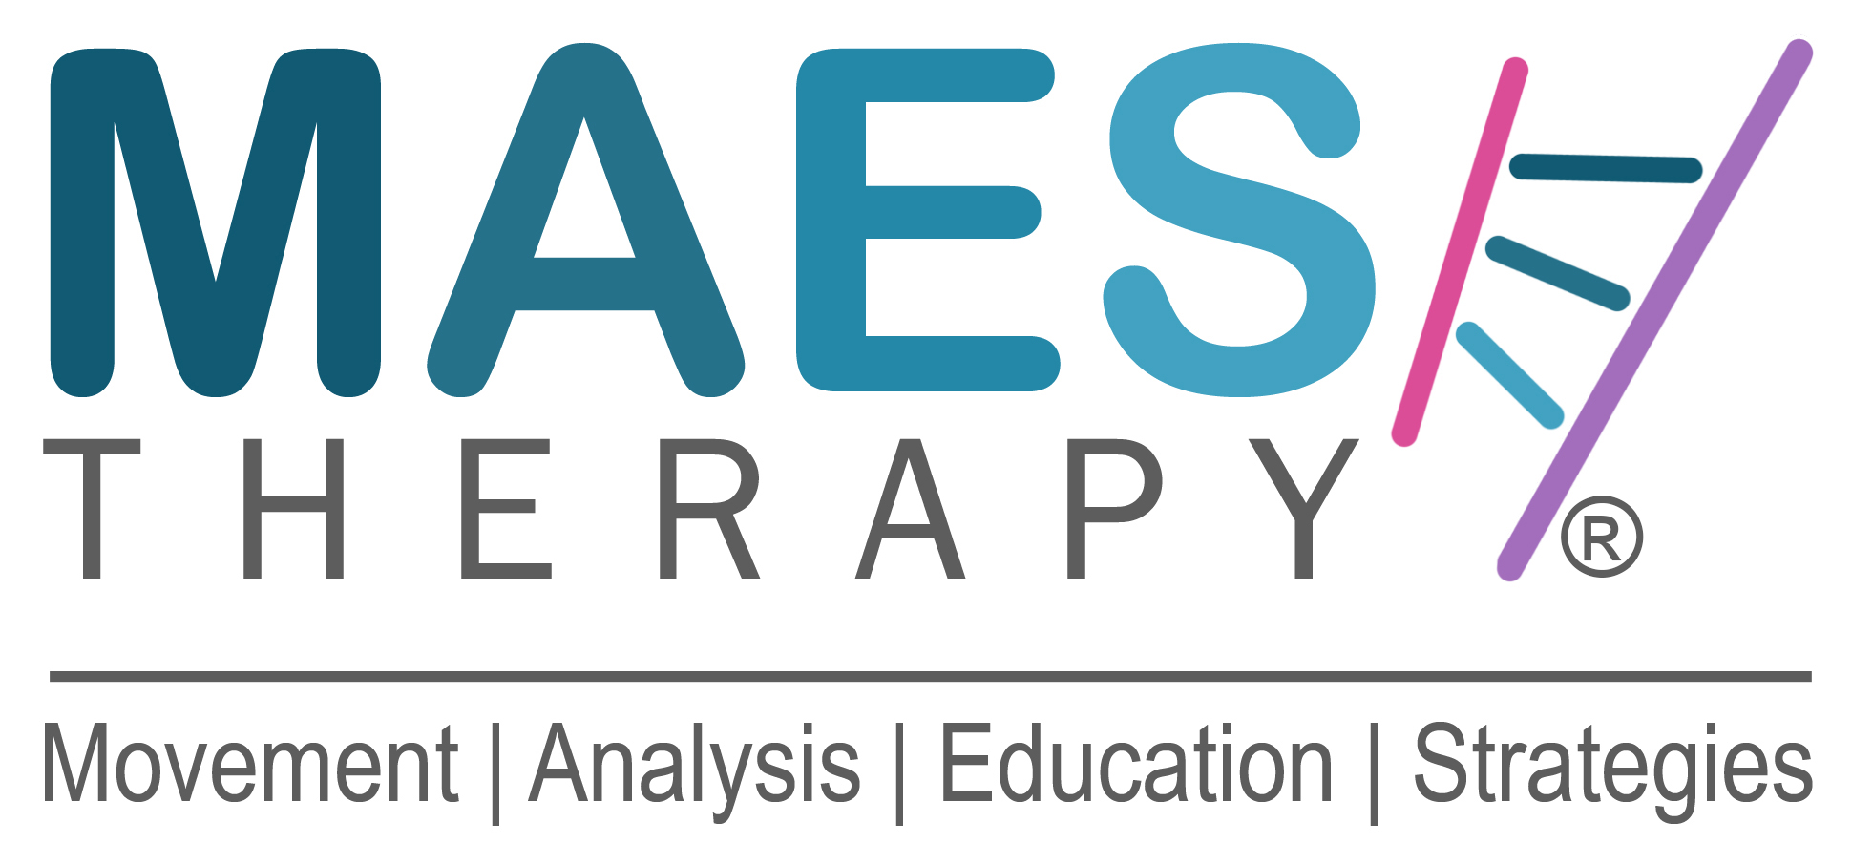

**Name:** First Name: Family Name:

**Profession & Job Title** (PT, OT, SLT, Doctor) :-

**Full Home Address:**

**Place of Work:**

E-mail Work:

E-mail Private: Private Mobile No:

**Insurance statement:**

*“By submitting this Application Form, I confirm that I am the person named on this form and I will be covered by my own Professional Liability Insurance if I attend this course”.*

Full Name ( Print your name ) :-

**_________________________________________________________________________**

**M.A.E.S. Course:**

***‘Movement Analysis & Education Strategies Course for children with Cerebral Palsy and similar neurodevelopmental conditions’***

**Length of Course:** 20-Days (4-Weeks) Post-graduate course in two parts of two weeks.

**Dates: Part**

**Part**

It is very helpful for Participants’ learning to plan and make arrangements to use the period between Part 1 and Part 2 to try putting into practice the knowledge gained in Part 1, before returning for Part 2.

**Venue for Part 2:** Finchley Golf Club,Frith Lane, Mill Hill East, **NW London** NW7 1PU

**Course Participants Criteria:**

Participants must be fully qualified Paediatric Therapists (Physiotherapists, Occupational Therapists, Speech Therapists) or medical Doctors (paediatricians, neurologists), with at least two years’ experience in treating children with Cerebral Palsy and similar neurological conditions. The course will appeal to therapists who are about to take their first postgraduate course in the field of Cerebral Palsy and equally as well as to very experienced therapists who have already taken several specialist courses.

M.A.E.S. is a completely different way of thinking and approach to treatment.

**Course Lead by:**

Jean-Pierre Maes MCSP Consultant Neurodevelopmental Physiotherapist,

Founder & Director M.A.E.S. Therapy International

and **M.A.E.S. Team UK:**

**How did you learn about this course?:**

CSP website / CSP email Bulletins / RCOT website / APCP / Facebook / Instagram / Linked-In

Other

**Course Fee:** Early Bird: £3,155.00 *To be paid by 30 April 2025*

Regular/Late Registration: £ 3,555.00

5% Discount per person for any two or more work colleagues that register together.

First come first served and a non-refundable* deposit of £500 secures your place.

*\*The deposit can only be refunded if a suitable replacement participant is found, and that person pays their deposit. Suitable, i.e. meets the Course Participants' Criteria.*

Please note that MAES Therapy is not registered for VAT.

**Application:**

1. To apply for a place on the course, please complete this Application Form

and together with your CV, **e-mail to**:

**Course Organiser**: **Jonathan Salsbury MIoD, Development Director,**

**M.A.E.S. Therapy International**

E: jsalsbury@maestherapy.com

2. **C.V.**

Please also attach your full Curriculum Vitae, including your full professional work experience.

3. **How to Pay:**

Once this Application Form and accompanying CV have been submitted and accepted, details about how to make the payments will be provided.

You will be sent an e-mail asking you to make payment of the Non-Refundable Deposit and later the Balance, with details of how to make the payments and into which bank accounts.

4. **Confirmation:** Upon receipt of the full Course Fee, you will receive an email confirming your Registration and place on the course ( subject to receipt of full payment by the deadline date).

**5. Notice:**

Arrangements for accommodation and travel should only be considered and booked once you   
 have a confirmed booking **and it is confirmed that there are sufficient numbers of participants   
 for the course to go ahead.** We are not able to reimburse expenses if the course is cancelled.

***M.A.E.S. Therapy is a pioneering evidence-based approach****, underpinned by practice evidence, patient evidence and contextual evidence from 30 years’ expert clinical and teaching experience world-wide and focusing on excellent treatment skills.*

**M.A.E.S.  M**ovement **A**nalysis **E**ducation **S**trategies **Therapy**

© 2013-2025 Copyright M.A.E.S. THERAPY International. All rights reserved.